Predictors and survival of Primary clear cell carcinoma of liver: a population-based study of an uncommon primary liver tumor
Jie Wen*¹, Abudureyimujiang Aili¹, Xueyan Yao¹, Lixiang Xue*, Junjie Wang*

Supplementary Material and Methods
Definition of Variables and Grouping criteria
Age was defined as the age at diagnosis as PCCCL and was classified into 2 grouops: “<75” and “≥75” years old. Race was recoded as follows: white, black, or others. The marital status was divided into six categories: married, divorced, widowed, single, separated and unknown. Sex was described as male and female. Grade was categorized into five sorts: “well differentiated (Grade I),” “moderately differentiated (Grade II),” “poor differentiated (Grade III),” “undifferentiated (Grade IV)” and “unknown”. Tumor size was assigned into three groups: “<1 cm”, “≥1cm” and “unknown”. AJCC T stage was classified as four subgroups: “T1”, “T2”, “T3” and “T4”. AJCC N stage was categorized into two subgroups: “N0” and “N1”. AJCC M stage was divided into two subgroups: “M0” and “M1”. AJCC stage was assigned into four groups: “I”, “II”, “III (IIIA, IIIB, IIIC)”, and “IV”. SEER stage was classified as three subgroups: “localized”, “regional” and “distant”. The radiotherapy was divided into two groups: “Yes” which means the patients underwent radiotherapy and “No” means not. The methods of surgery was assigned into the following six types: “none”, “local tumor destruction”, “local tumor excision”, “wedge or segmental resection/partial proctosigmoidectomy”, “total proctectomy”, “total colectomy” and “total proctectomy plus total colectomy”. Tumor extension was categorized as follows: “no vascular invasion”, “intrahepatic vascular invasion”, “gallbladder extension”, “intrahepatic vascular invasion plus gallbladder extension”, “surface of parenchyma extension”, “major vascular invasion: major branch(es) of portal or hepatic vein(s)”, “hepatic artery or vena cava invasion”, “coronary, falciform, hepatoduodenal, hepatogastric, round (of liver), triangular, perforation of visceral peritoneum, parietal peritoneum, pancreas, pleura, stomach extension” and “unknown”. Regional nodes metastasis was divided into two groups: “Yes” and “No”. Distant nodes metastasis was divided as follows: “Yes” and “No”. Lymphnode surgery was subdivided into five groups: “none”, “1 to 3 regional lymph nodes removed”, “4 or more regional lymph nodes removed”, “biopsy or aspiration of regional lymph node, NOS” and “number of regional lymph nodes removed unknown”. Insurance status was subdivided into five categories: “insured”, “uninsured”, “any medicaid”, “any medicaid”, “insurance status unknown” and “blank(s)”.

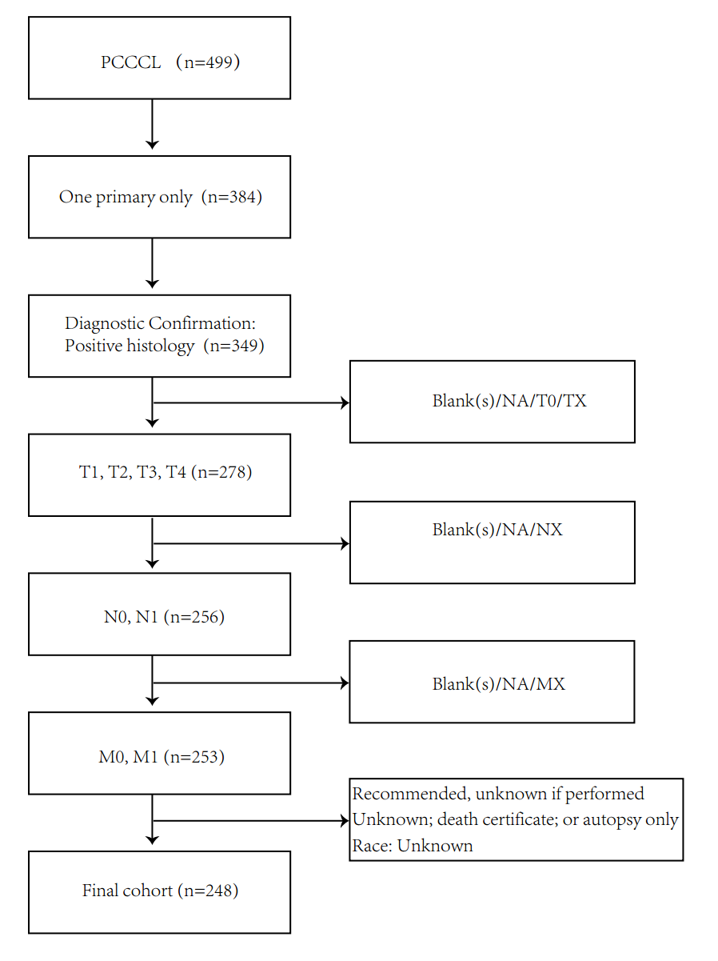
Supplementary Figure 1: Flow diagram of study cohort selection. A ﬂow diagram describing the inclusion and exclusion criteria for the patient selection. The exclusion criteria were as follows: ① Diagnostic confirmation that is not “positive histology” ② Sequence number that is not “One primary only”; ③ AJCC T that is “TX, T0, NA, or blank”; ④ AJCC N that is “NX, NA, or blank”; ⑤ AJCC M that is “MX, NA, or blank”; ⑥ Reason no cancer-directed surgery that is “Recommended, unknown if performed” and “Unknown; death certificate; or autopsy only”; ⑦ Race recode that is “Unknown”.

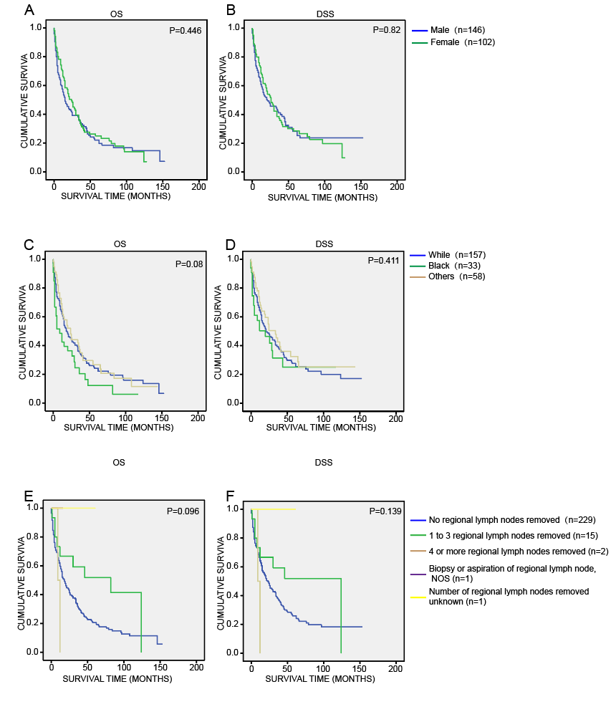
Supplementary Figure 2: Kaplan–Meier analysis of the variables. Kaplan-Meier estimates of the OS and DSS stratified by (A-B) sex, (C-D) race, (E-F) regional lymph node resection.
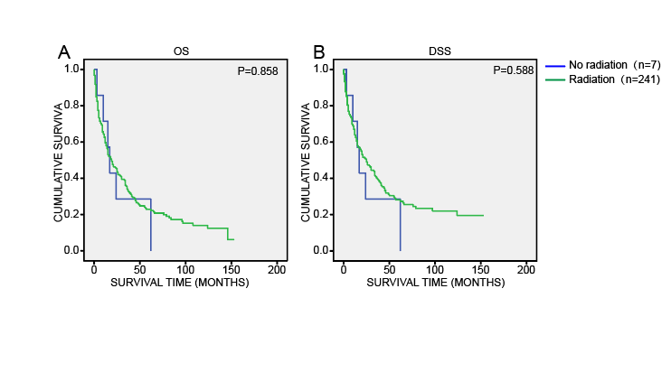
Supplementary Figure 3: Kaplan–Meier analysis of the variables. Kaplan-Meier estimates of the OS and DSS stratified by (A-B) radiotherapy.

Supplementary Table 1：Characteristics of patients with PCCCL diagnosed from 2004 to 2016 obtained from the SEER database.
Age at diagnosis, mean ± SD |  | 64.1 ± 12.3
Parameter | Subgroup | Number of patients (%)
Age  Sex | <75 | 201（81）
Age  Sex | ≥75 | 47（19）
Age  Sex | Male | 146（58.8）
Marital status | Female | 102（41.2）
Marital status | Married | 149（60.1）
Race | Divorced | 21 (8.5)
Race | Widowed | 4 (1.6)
Race | Single | 38 (15.3)
Race | Separated | 8 (3.2)
Race | Unknown | 28 (11.3)
Race | White | 157 (63.3)
Tumor size, (cm)  T stage  N stage  M stage  AJCC Stage  Summary Stage  Radiation  Surgery  Extension  Regional lymph nodes metastasis  Distant lymph nodes metastasis  Lymphnode surgery  Pathological grade (Edmondson’s classification)  Insurance | Black | 58 (23.4)
 | Others | 33 (13.3)
 | <1 cm | 169 (68.1)
 | ≥1cm | 57 (23)
 | Unknown | 22 (8.9)
 | T1 | 123 (49.6)
 | T2 | 48 (19.4)
 | T3 | 60 (24.2)
 | T4 | 17 (6.8)
 | N0 | 236 (95.2)
 | N1 | 12 (4.8)
 | M0 | 213 (85.9)
 | M1 | 35 (14.1)
 | I | 109 (44)
 | II | 44 (17.7)
 | IIIA | 46 (18.5)
 | IIIB | 10 (4)
 | IIIC | 4 (1.6)
 | IV | 35 (14.2)
 | Localized | 152 (61.3)
 | Regional | 58 (23.4)
 | Distant | 38 (15.3)
 | Yes | 7 (2.8)
 | No | 241 (97.2)
 | None | 128 (51.6)
 | Local tumor destruction | 21 (8.5)
 | Local tumor excision | 50 (20.2)
 | Wedge or segmental resection/partial proctosigmoidectomy | 28 (11.3)
 | Total proctectomy | 1 (0.4)
 | Total colectomy | 3 (1.2)
 | Total proctectomy+Total colectomy | 17 (6.8)
 | No vascular invasion | 152 (61.3)
 | Intrahepatic vascular invasion | 24 (9.7)
 | Gallbladder extension | 3 (1.2)
 | Intrahepatic vascular invasion+ Gallbladder extension | 1 (0.4)
 | Surface of parenchyma extension | 29 (11.7)
 | Major vascular invasion: major branch(es) of portal or hepatic vein(s) | 4 (1.6)
 | Hepatic artery or vena cava invasion | 19 (7.7)
 | Coronary, Falciform, Hepatoduodenal, Hepatogastric, Round (of liver), Triangular, Perforation of visceral peritoneum, Parietal peritoneum, Pancreas, Pleura, Stomach extension | 5 (2)
 | Unknown | 11 (4.4)
 | Yes | 12 (4.8)
 | No | 236 (95.2)
 | Yes | 35 (14.1)
 | No | 213 (85.9)
 | None | 229 (92.3)
 | 1 to 3 regional lymph nodes removed | 15 (6.1)
 | 4 or more regional lymph nodes removed | 2 (0.8)
 | Biopsy or aspiration of regional lymph node, NOS | 1 (0.4)
 | Number of regional lymph nodes removed unknown | 1 (0.4)
 | Well differentiated; Grade I | 40 (16.1)
 | Moderately differentiated; Grade II | 85 (34.3)
 | Poorly differentiated; Grade III | 28 (11.3)
 | Undifferentiated; anaplastic; Grade IV | 3 (1.2)
 | Unknown | 92 (37.1)
 | Insured | 139 (56)
 | Uninsured | 7 (2.8)
 | Any Medicaid | 48 (19.4)
 | Insurance status unknown | 5 (2)
 | Blank(s) | 49 (19.8)
Supplementary Table 1：The characteristics of patients.
Supplementary Table 2: Final model
Parameter | Subgroup | Overall survival |  |  | Disease-free survival
 |  | Hazard ratio | (95 % CI) | P value | Hazard ratio | (95 % CI) | P value
Insurance |  |  |  | 0.222 |  |  | 0.196
 | Insured | 1 |  |  | 1
 | Uninsured | 2.284 | (0.96,5.43) | 0.061 | 1.841 | (0.71,4.75) | 0.207
 | Any Medicaid | 1.259 | (0.83,1.91) | 0.282 | 1.442 | (0.93,2.23) | 0.1
 | Insurance status unknown | 0.804 | (0.23,2.81) | 0.732 | 1.122 | (0.26,4.82) | 0.876
 | Blank(s) | 1.357 | (0.91,2.03) | 0.136 | 1.558 | (1.01,2.4) | 0.045
Race |  |  |  | 0.077
 | White | 1
 | Black | 1.214 | (0.83,1.77) | 0.317
 | Others | 1.714 | (1.06,2.78) | 0.029
Tumor size, (cm) |  |  |  | 0.000 |  |  | 0.000
 | <1 cm | 1 |  |  | 1
 | 》1cm | 2.139 | (1.47,3.12) | 0.000 | 2.347 | (1.57,3.51) | 0.000
 | Unknown | 2.076 | (1.21,3.58) | 0.009 | 1.854 | (1.03,3.33) | 0.039
Marital status |  |  |  | 0.158 |  |  | 0.051
 | Married | 1 |  |  | 1
 | Divorced | 1.18 | (0.67,2.08) | 0.569 | 1.533 | (0.86,2.73) | 0.147
 | Widowed | 1.854 | (1.14,3.02) | 0.013 | 2.169 | (1.3,3.63) | 0.003
 | Single | 1.407 | (0.9,2.21) | 0.138 | 1.604 | (1.01,2.56) | 0.047
 | Separated | 1.761 | (0.6,5.2) | 0.305 | 1.283 | (0.38,4.35) | 0.689
 | Unknown | 0.902 | (0.35,2.35) | 0.833 | 1.195 | (0.47,3.07) | 0.711
Surgery |  |  |  | 0.000 |  |  | 0.000
 | None | 1 |  |  | 1
 | Local tumor destruction | 0.486 | (0.28,0.85) | 0.011 | 0.528 | (0.2,0.71) | 0.003
 | Local tumor excision | 0.268 | (0.17,0.42) | 0.000 | 0.36 | (0.17,0.45) | 0.000
 | Wedge or segmental resection/partial proctosigmoidectomy | 0.23 | (0.13,0.4) | 0.000 | 0.297 | (0.14,0.44) | 0.000
 | Total proctectomy | 0.421 | (0.06,3.19) | 0.402 | 1.101 | (0.07,3.94) | 0.532
 | Total colectomy | 0.306 | (0.07,1.31) | 0.110 | 0.315 | (0.02,1.36) | 0.096
 | Total proctectomy+Total colectomy | 0.103 | (0.05,0.24) | 0.000 | 0.072 | (0.03,0.21) | 0.000
Supplementary Table 2：Tumor size (cm), marital status and surgery were independently associated with the OS and DSS of the patients. Insurance status was independently associated with the DSS. Race was independently associated with the OS.

Supplementary Table 3: Factors associated with higher AJCC stage in Ordered Logistic Regression.
Model fitting information |  | P value=0.022
Parallel Line Assumption |  | P value=0.165
Parameter | Subgroup | Estimated value  (95 % CI) | P value
Pathological grade | Grade I | -1.062 (-1.8,-0.33) | 0.005
Pathological grade | Grade II | -0.365 (-0.92,0.9) | 0.197
Pathological grade | Grade III | 0.002 (-0.78,0.79) | 0.996
Pathological grade | Unknown | 1.446 (-0.70,3.59) | 0.187
Pathological grade | Grade IV | Reference
Sex | Male | 0.084 (-0.40,0.57) | 0.736
Sex | Female | Reference
Race | White | 0.443 (-0.27,1.15) | 0.222
Race | Others | 0.210 (-1.03,0.61) | 0.614
Race | Black | Reference
Age | <45 | 0.570 (-0.05,1.19) | 0.072
Age | ≥45 | Reference
Supplementary Table 3：The pathological grade was associated with the AJCC stage. Abbreviations: OR, odds ratio.

